**Bodha SERvice KT Document**

# List of Content

1. Technology Details
2. Code Walkthrough
   * Package description
   * Application Introduction
   * Maven Dependencies
   * Entity description
   * login using spring security
   * Controller, Service and Repository
   * Database connection configure description using yml
   * Testing
   * Dev and Prod environment details
   * Run and build the application
   * Application Dev and Prod environment (pcf) details and url description
   * GitHub Details

|  |
| --- |
| Technology |
| Spring Boot |
| Java |
| MySQL |
|  |
| Maven |
| JUnit |
| Concourse |
| Fly |
| GitHub |

**1.Technology Details**

**2.Code Walkthrough**

* Package description:

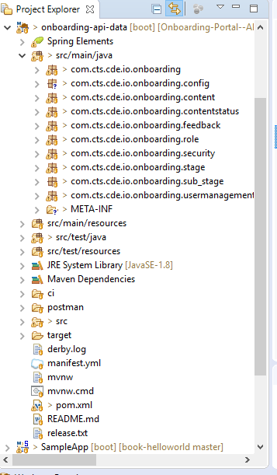

* Application Introduction:
* Bodha Server api is written as SpringBootApplication and main class named as OnBoardingApplication.java
* *Spring Boot* provides a number of “Starters” that make easy to add jars to your classpath. Our *application* has already used ***spring*-*boot*-starter-parent** in the parent section of the **POM**. The *spring*-*boot*-starter-parent is a special starter that provides useful Maven defaults. It also provides a dependency-management.

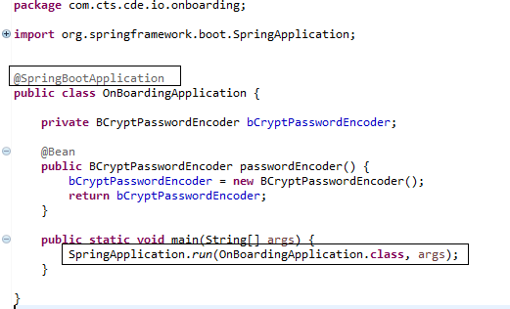

* Maven Dependencies.

Declared all related maven dependency to pom.xml. Below are the few of them:

<dependencies>

<! -- Starter for using Spring Data **JPA with Hibernate** -->

*<dependency>*

*<groupId>org.springframework.boot</groupId>*

*<artifactId>spring-boot-starter-data-jpa</artifactId>*

*</dependency>*

<! -- Starter for exposing Spring Data repositories over **REST using Spring Data** REST -->

*<dependency>*

*<groupId>org.springframework.boot</groupId>*

*<artifactId>spring-boot-starter-data-rest</artifactId>*

*</dependency>*

<! -- Starter for **building web, including RESTful, applications using Spring MVC**. Uses Tomcat as the default embedded container -->

*<dependency>*

*<groupId>org.springframework.boot</groupId>*

*<artifactId>spring-boot-starter-web</artifactId>*

*</dependency>*

<! -- Starter for testing Spring Boot applications with libraries including **Junit, Mockito** -->

*<dependency>*

*<groupId>org.springframework.boot</groupId>*

*<artifactId>spring-boot-starter-test</artifactId>*

*<scope>test</scope>*

*</dependency>*

<! -- JDBC Type 4 **driver for MySQL** -->

*<dependency>*

*<groupId>mysql</groupId>*

*<artifactId>mysql-connector-java</artifactId>*

*<scope>runtime</scope>*

*</dependency>*

<! -- Starter for using **Spring Security** -->

*<dependency>*

*<groupId>org.springframework.boot</groupId>*

*<artifactId>spring-boot-starter-security</artifactId>*

*</dependency>*

<! -- **JSON Web Token Support** for The JVM -->

*<dependency>*

*<groupId>io.jsonwebtoken</groupId>*

*<artifactId>jjwt</artifactId>*

*<version>0.7.0</version>*

*</dependency>*

<! -- **Gson** -->

*<dependency>*

*<groupId>com.google.code.gson</groupId>*

*<artifactId>gson</artifactId>*

*<version>2.8.2</version>*

*</dependency>*

<! -- **Apache HttpComponents** Client -->

*<dependency>*

*<groupId>org.apache.httpcomponents</groupId>*

*<artifactId>httpclient</artifactId>*

*<version>4.5.3</version>*

*<scope>test</scope>*

*</dependency>*

<! -- **json** -->

*<dependency>*

*<groupId>org.json</groupId>*

*<artifactId>json</artifactId>*

*<version>20080701</version>*

*</dependency>*

<! -- **Spring Context Support** -->

*<dependency>*

*<groupId>org.springframework</groupId>*

*<artifactId>spring-context-support</artifactId>*

*<version>3.2.0.RELEASE</version>*

*</dependency>*

</dependencies>

* Entity description:

We have entities namely User, Role, Stage, Substage, Content, Content Status and Feedback.

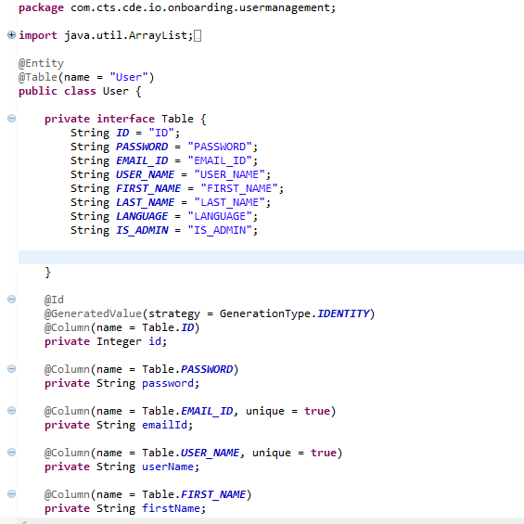

Here in above screenshot we can see the User Entity with table name **User**

corresponding column declarations. Same as like we have for other entities.

* Login using spring security:
* We have used Spring security for login to Bodha portal. Spring Security is a framework which provides various security features like: authentication, authorization to create secure Java Enterprise Applications.
* JSON Web Tokens, commonly known as JWTs, are tokens that are used to authenticate users on applications. During the authentication process, when a user successfully logs in using their credentials, a JSON Web Token is returned and must be saved locally (typically in local storage). Whenever the user wants to access a protected route or resource (an endpoint), the user agent must send the JWT, usually in the Authorization header using the [Bearer schema](http://self-issued.info/docs/draft-ietf-oauth-v2-bearer.html), along with the request.

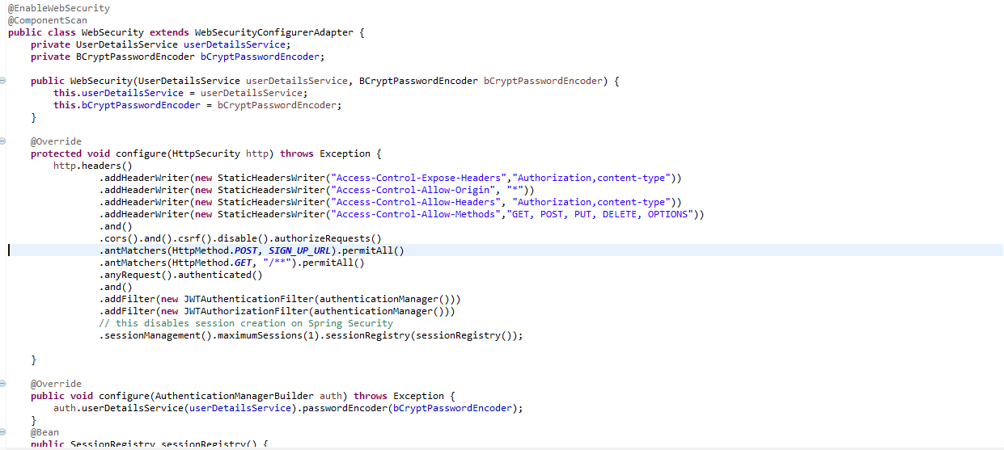

**UserDetailsService:**

If we want to use any DAO class for authentication, we need to implement UserDetailsService interface. Once the DAO is configured, it’s loadUserByUsername() is used to validate the user.

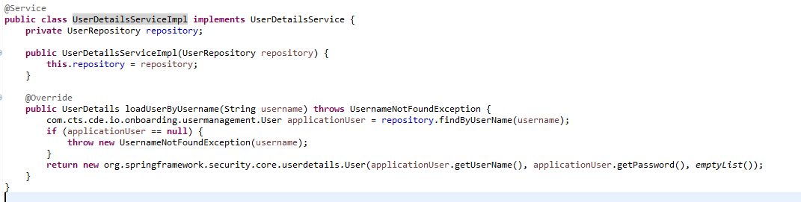

* Controller, Service and Repository:

Corresponding to every module such as User, Role, Content, Content Status, Feedback, Stage and Substage we have separate controllers, Service and Repositories.

* Presentation Layer: Controller (@Controller)
* Application Service Layer: Application Service (@Service)
* Domain Layer: Model, Domain Service (@Service), Repository (@Repository)
* Database connection configure description using yml:

Spring Boot has excellent support for YAML configuration. In our YML we have database connection properties and server port declaration and flyway db migration. Below is the yml screenshot.

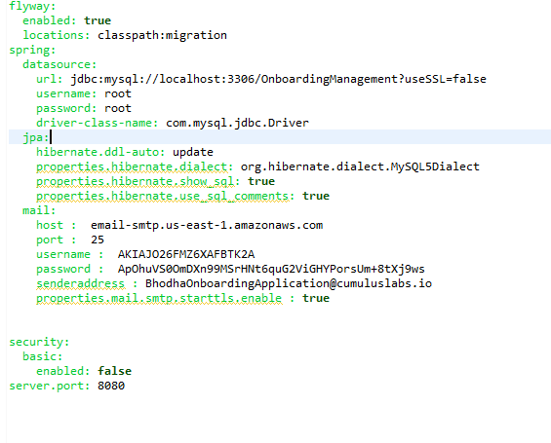

* Testing:

We have written Junit test cases for each class and integration test for the application. Have used Mockito. Mockito is a popular mock framework which can be used in conjunction with JUnit.

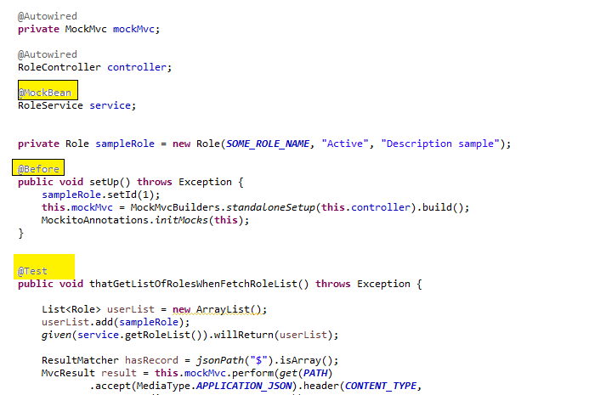

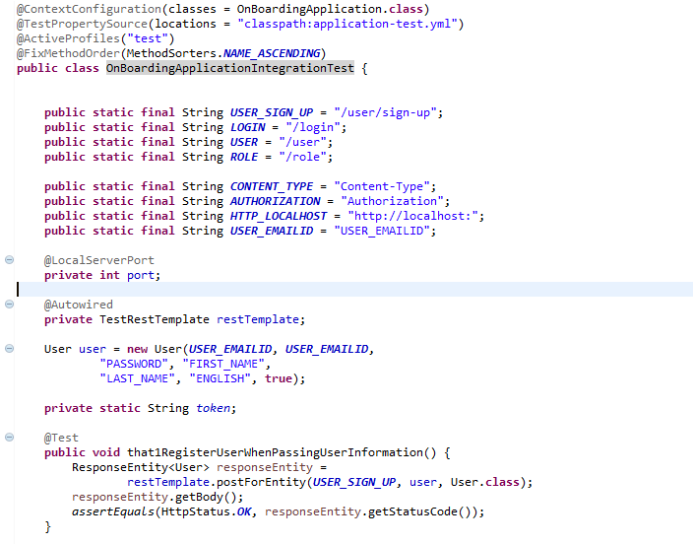

* Run and build the application:
* Run: mvn spring-boot:run
* Build: mvn clean package
* Application Dev and Prod Urls:

**DEV API URL:**

[**https://bodha-apijsoningnore.app.dev.digifabricpcf.com/**](https://bodha-apijsoningnore.app.dev.digifabricpcf.com/)

**PROD API URL:**

[**https://bodhaapi.app.dev.digifabricpcf.com/**](https://bodhaapi.app.dev.digifabricpcf.com/)

* GitHub Details:

<https://github.com/TheCognizantFoundry/Onboarding-Portal--API.git>